Recoil Starter Repair Kit

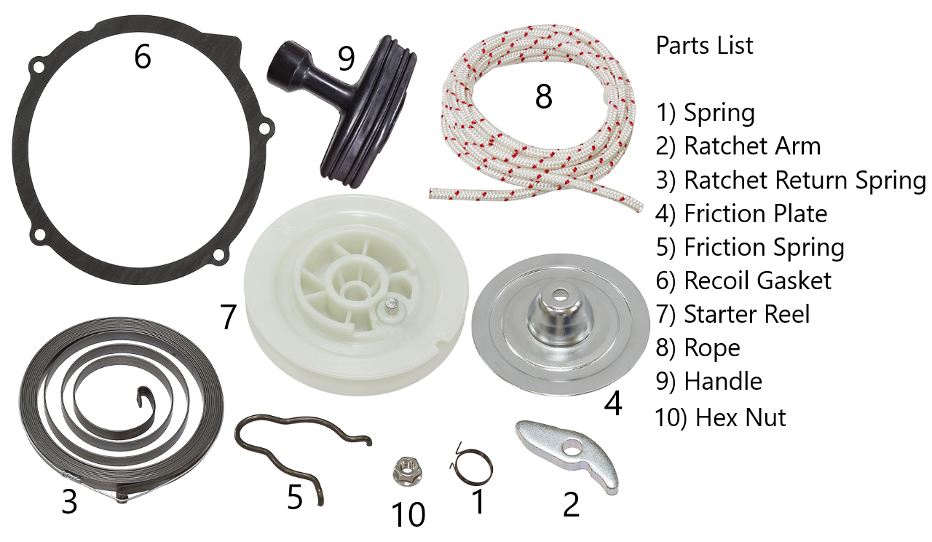


We highly recommend this repair be performed by a licensed service technician. Please read the instructions completely before beginning. Recoil starters are spring loaded so always wear eye
protection

Disassembly Instructions

1) Remove the starter recoil unit from the machine using the specific model year service manual.
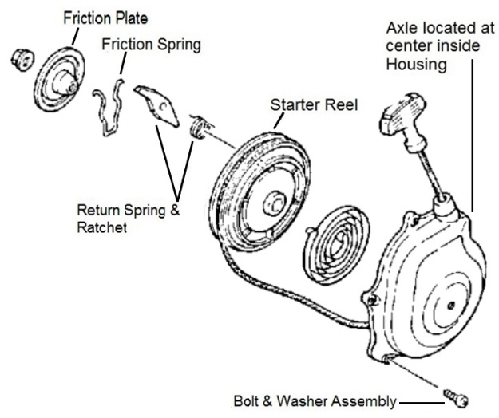
2) The spring is attached to the rear of the starter reel and may still be loaded; it is a hazard so be prepared to constrain it while removing it from the cover.
3) Remove the nut assembly being careful not to allow the spring to suddenly release.
a. Remove the friction plate and friction spring (the friction Spring is on the back of the friction plate).
b. Remove the return spring and ratchet.
4) Carefully lift the starter reel and Spring up and out of the unit using caution in case the spring abruptly uncoils.
5) Cut or untie the pull rope from the Starter Reel.
6) Thoroughly clean the interior making sure to remove any gasket material, grease, grime, or mud from the recoil housing and the mating surface on the vehicle.

Assembly Instructions


The Reel Spring is pre‐loaded and must not be removed from the capture ring until instructed to do so.

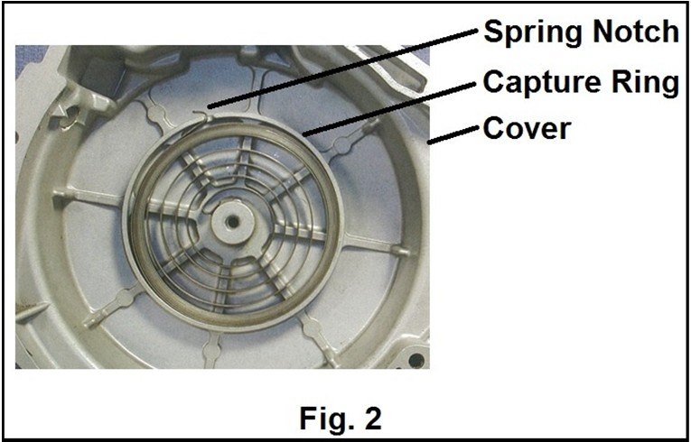
1) Position the spring into the capture area inside the housing cover placing the hooked end in the notch.
See Fig. 2.
2) While firmly holding the spring plate flat in the bottom of the cover carefully begin pulling the capture ring off by releasing one side then the other. If done correctly the spring should be constrained. IMPORTANT: Be sure to keep the cover flat and all parts securely pushed into the cover until the nut has been installed. This will prevent the recoil spring from uncoiling.
3) Install the starter reel onto the axle and position it so that the plastic back center of reel will catch the hooked center end of the spring. See Fig. 3.
a. Begin winding the reel clockwise 1/2 turn to make sure the reel has caught the spring.
Then release and it should return to its starting position.
b. Install the Ratchet Return Spring on the pin. The long tang is installed to the reel and the ratchet catching the short tang of the return spring in the notch.
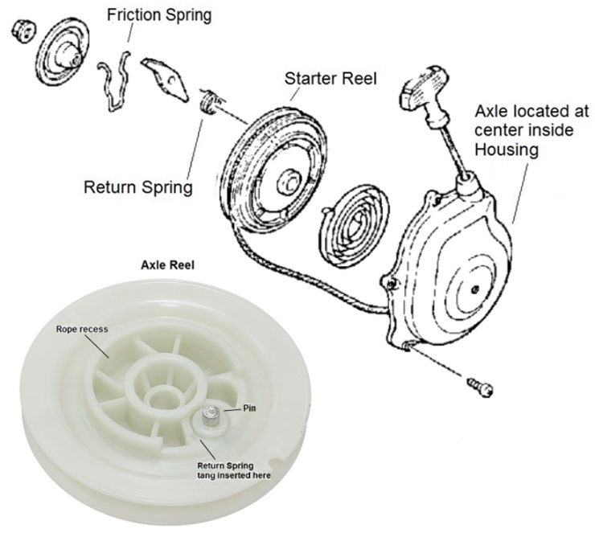
4) Install the friction spring onto the friction plate with the tang ends of the spring facing out.
5) Install the ratchet arm onto the pin located on the reel. The groove on the bottom of the ratchet arm should line up with short tab of the return spring.
6) Flip the friction plate with attached spring over and
position it onto the reel so the tang ends and loop of the spring are in the center recessed area. The friction plate should have about 20° of play before causing the ratchet to engage.
7) Secure the friction plate and reel assembly to the
axle with the 6mm hex nut.
8) Begin winding the reel 6 complete turns clockwise. Position a wide blade screwdriver in the notch to prevent the reel from unwinding.
from the outside aligning it with the opening in the reel. Use a needle nosed pliers to grasp the end of the rope and pull it through the opening.
09) Tie a knot in the rope end making sure to leave about 2" extra at end. Tie a second overhand knot at
that end and tighten the knots against each other.
10) Pull the rope to the outside of the cover to take up the slack. Then push the knot securely into the recessed opening on the reel.
11) Hold the Reel while removing the screwdriver and allow the reel to slowly recoil.
12) Check that the recoil unit is working properly by pulling the rope and observing that the ratchet pops out when the rope is pulled and then retracts when
13) Install the rubber handle onto the recoil rope stem with the remainder of slack.

*not all applications will utilize included case gasket

The rebuilt recoil assembly is now ready to be reinstalled on the vehicle. Use the specific vehicle service manual for the proper procedure. Not all vehicle applications will need the Gasket that is included.

